Assignment No 3 (Group B)

Problem Statement:- Locate dataset (eg. sample_weather.txt) for working on weather data

which reads the text input files and finds average for temperature, dew point and wind speed.

**Introduction:-**

Support Vector Machine:-

“Support Vector Machine” (SVM) is a supervised machine learning algorithm that can be used

for both classification or regression challenges. However, it is mostly used in classification

problems. In the SVM algorithm, we plot each data item as a point in n-dimensional space

(where n is a number of features you have) with the value of each feature being the value of a

particular coordinate. Then, we perform classification by finding the hyper-plane that

differentiates the two classes very well

Generally, Support Vector Machines is considered to be a classification approach, it but can be

employed in both types of classification and regression problems. It can easily handle multiple

continuous and categorical variables. SVM constructs a hyperplane in multidimensional space

to separate different classes. SVM generates optimal hyperplane in an iterative manner, which

is used to minimize an error. The core idea of SVM is to find a maximum marginal

hyperplane(MMH) that best divides the dataset into classes.

**How does it work?**

The main objective is to segregate the given dataset in the best possible way. The distance

between the either nearest points is known as the margin. The objective is to select a

hyperplane with the maximum possible margin between support vectors in the given dataset.

SVM searches for the maximum marginal hyperplane in the following steps:

1. Generate hyperplanes which segregates the classes in the best way. Left-hand side figure

showing three hyperplanes black, blue and orange. Here, the blue and orange have

higher classification error, but the black is separating the two classes correctly.

2. Select the right hyperplane with the maximum segregation from the either nearest data

points as shown in the right-hand side figure.

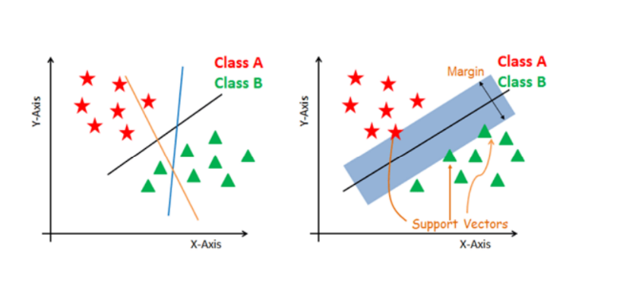

**Dealing with non-linear and inseparable planes**

Some problems can’t be solved using linear hyperplane, as shown in the figure below (left-

Some problems can’t be solved using linear hyperplane, as shown in the figure below(Left-hand side).

In such situation, SVM uses a kernel trick to transform the input space to a higher dimensional

space as shown on the right. The data points are plotted on the x-axis and z-axis (Z is the

squared sum of both x and y: z=x^2=y^2). Now you can easily segregate these points using

linear separation.

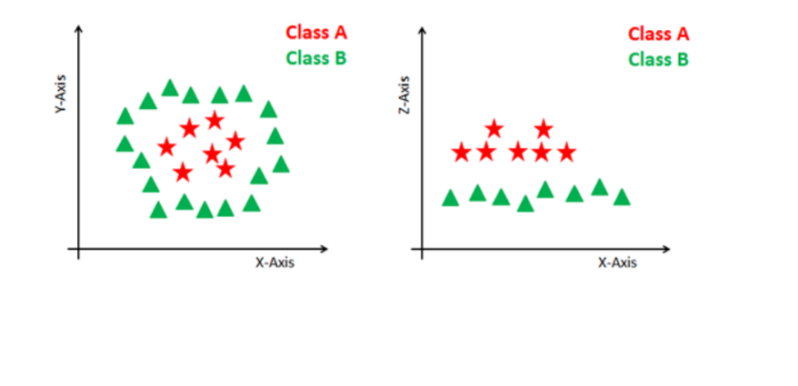

**The advantages of support vector machines are:**

• Effective in high dimensional spaces.

• Still effective in cases where number of dimensions is greater than the number of samples.

• Uses a subset of training points in the decision function (called support vectors), so it is also memory efficient.

• Versatile: different Kernel functions can be specified for the decision function. Common kernels are provided, but it is also possible to specify custom kernels.

**The disadvantages of support vector machines include:**

• If the number of features is much greater than the number of samples, avoid over-fitting in choosing Kernel functions and regularization term is crucial.

• SVMs do not directly provide probability estimates, these are calculated using an expensive five-fold cross-validation (see Scores and probabilities, below).

Implementation:-

Step 1:- Download dataset from below link https://github.com/shubhomoydas/ad_examples/blob/master/datasets/weather/weather_data.zip

Step 2:- Combine feature and target var in one data frame

Step 3:- Add column name to above dataset(Like Iris flower dataset-add column name)

Step 4:- Find statistics(Mean, Mode, Median) using python code(which we used in previous assignment)

Step 5:- find out missing/NA values

Step 6:-Find Outliers

Step 7:- Use SVM for Prediction(instead of logistic use SVM)

# Apply SVM regression

from sklearn.linear_model import SVMRegression

model = SVMRegression()

model.fit(X_train,Y_train)

print('Model Score: ', model.score(X_test, Y_test))

Question:-

1) What do know about Hard Margin SVM and Soft Margin SVM?

2) Explain SVM

3) What are Support Vectors in SVMs

4) What is the basic principle of a Support Vector Machine?

5) What happens when there is no clear Hyperplane in SVM

6) Compare SVM and Logistic Regression in handling outliers

7) When SVM is not a good approach?